Phase 2: SIEM Dashboard Analysis (Using Splunk)

Catalog
1: Install Splunk in Kali Linux 2
1.1. Download Splunk 2
1.2. Install Splunk 2
1.3 Open Splunk Web 3
2: Create Log Files 3
2.1 On Kali Linux (Attacker) 3
2.2. On Metasploitable3 (Victim) 3
3. Add Logs to Splunk 4
4.: Search Logs 5
5.Create Dashboard 5
6: Compare Attacker vs Victim Logs 5

1: Install Splunk in Kali Linux

1.1. Download Splunk
- Open Firefox in Kali
- Go to: https://www.splunk.com
- Click "Free Splunk" > Choose Splunk Enterprise
- Select Linux .deb (64-bit) and click Download
- Sign up (or log in) to download the file
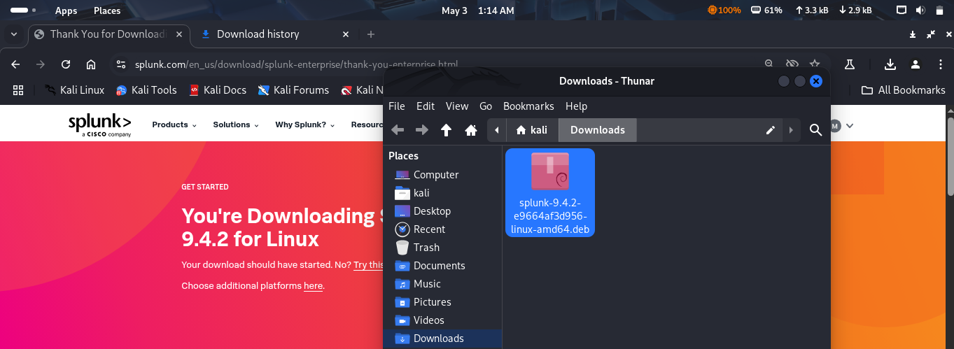

1.2. Install Splunk
- Open Terminal in Kali
- Go to your Downloads folder:
cd ~/Downloads
- Install Splunk:
sudo dpkg -i splunk-9*.deb
- After installation, start Splunk:
sudo /opt/splunk/bin/splunk start --accept-license

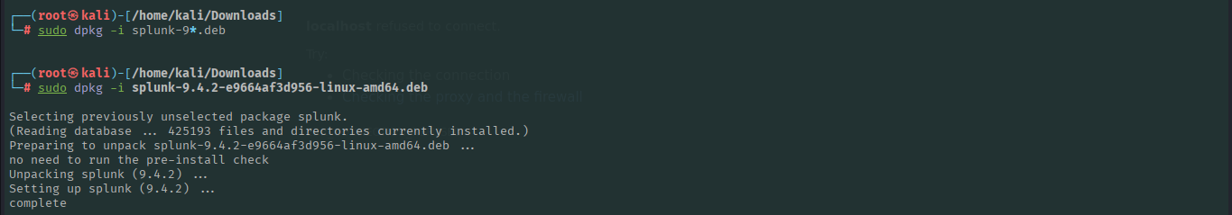
- It will ask for a username and password. Set them to:

1.3 Open Splunk Web
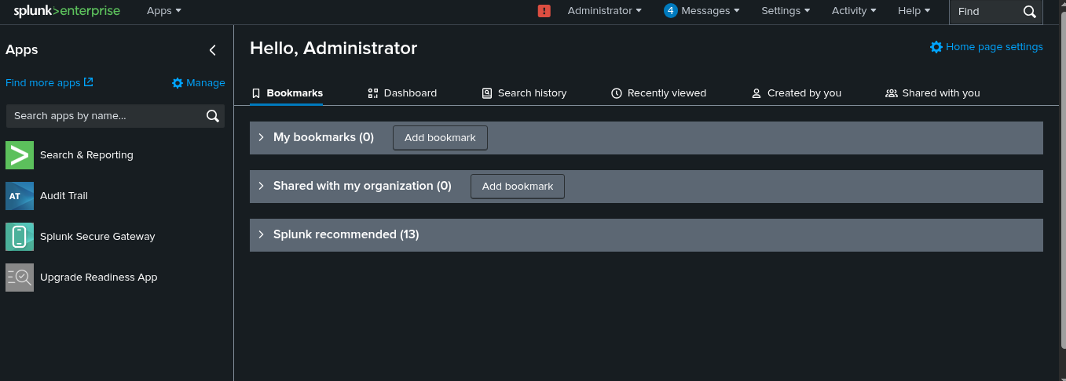

2: Create Log Files

2.1 On Kali Linux (Attacker)
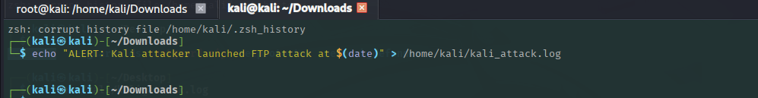

2.2. On Metasploitable3 (Victim)

3. Add Logs to Splunk
In Splunk Web:
- Go to "Add Data"
- Click Upload
- Choose kali_attack.log file
- When asked, set:
  - Source Type: attacker_log
- Click Next > Review > Submit
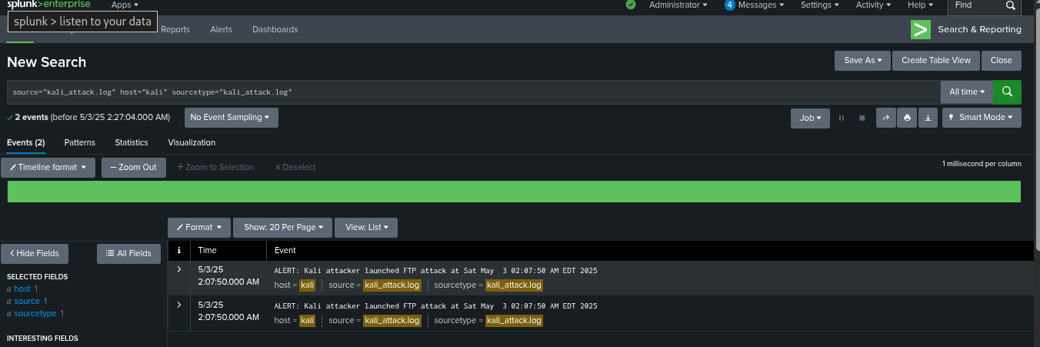
Repeat the same:
- Upload victim_log.txt
- Source Type: victim_log
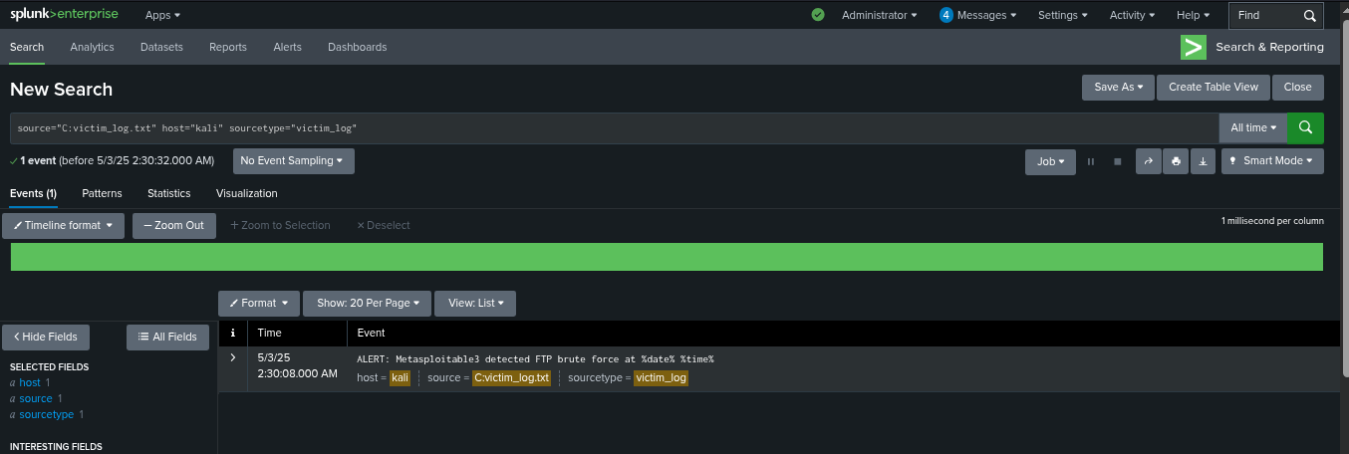

4.: Search Logs
In Splunk, click Search & Reporting
In search box, type:
sourcetype="attacker_log" OR sourcetype="victim_log"
Press Search
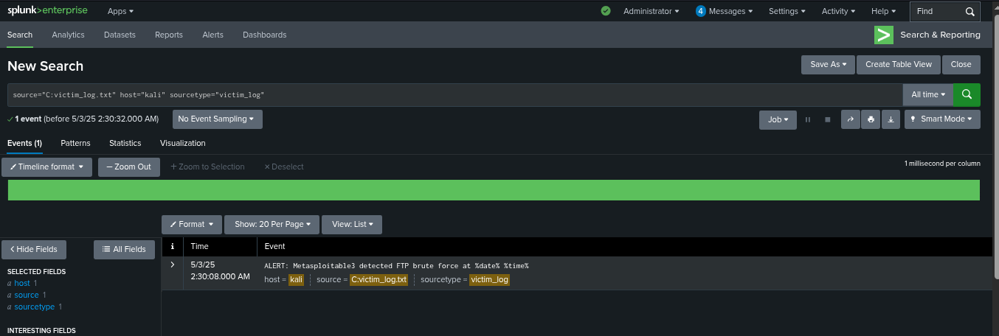

5.Create Dashboard
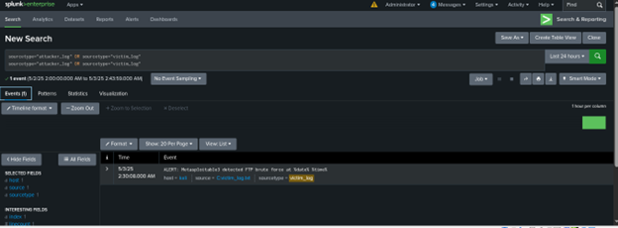

6: Compare Attacker vs Victim Logs
In your mind (and in your report), say:
- Attacker log: shows that the attack started from Kali
- Victim log: shows that Metasploitable3 detected the attack
- IPs and timestamps match
- This proves the attack happened and was logged by both systems

